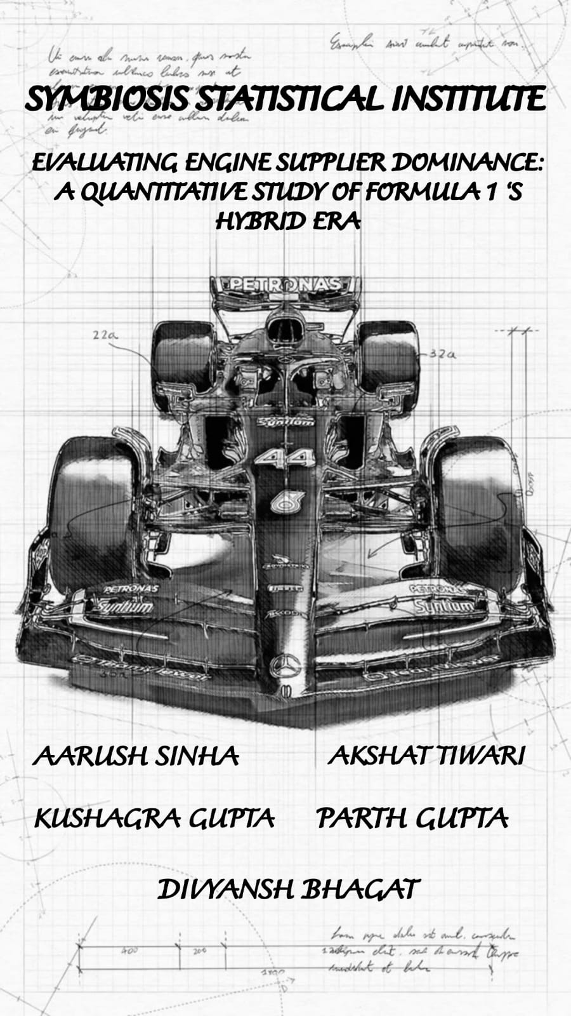


“EVALUATING ENGINE SUPPLIER DOMINANCE:
A QUANTITATIVE STUDY OF FORMULA 1 ‘S HYBRID ERA”

SUBMITTED BY :-
AARUSH SINHA (25060622059)
PARTH GUPTA (25060622081)
KUSHAGRA GUPTA (25060622047)
AKSHAT TIWARI (25060622080)
DIVYANSH BHAGAT (25060622030)

SUBMITTED TO: -
DR. SIVADASA PRABHU

CONTRIBUTION
- Define the research objective.
- Identify and define variables.
- Collect relevant data.
- Enter data into MS Excel.
- Calculate measures of central tendency.
- Compute variance, standard deviation, quartiles, and coefficient of variation.
- Plot data and create graphs.
- Analyse and draw conclusions.
- Prepared the project report.
- Developed the PowerPoint presentation.
- Write the project script.
- Compile the final word document.

:- AARUSH SINHA, AKSHAT TIWARI, KUSHAGRA GUPTA, PARTH GUPTA, DIVYANSH BHAGAT

TOPIC INTRODUCTION

Formula 1, or F1, is the world’s fastest and most popular motorsport, known for speed, technology, and thrilling races. Formula 1 is the fastest form of motorsport where drivers compete in a series of races worldwide, earning points based on their finishing position. Points are awarded to the top 10 finishers, with 25 points for first place, 18 for second, and 15 for third, decreasing to 1 point for tenth. These points add up over the season to crown the Drivers' and Constructors' Champions. The heart of every F1 car is its engine, provided by four main companies: Ferrari, Mercedes, Renault, and Honda. Each has a rich history in racing and engineering. In this project, our objective is to analyse the best engine-providing company. In Formula 1, time is everything—races are won and lost by fractions of a second. Precision timing tracks every moment of the race, from lap times to pit stops, where crews change tires in just a few seconds. Teams use real-time data and split-second decisions to manage strategy, tire wear, and fuel, adapting to race conditions instantly. Efficient time management, both on and off the track, is crucial for maximizing performance and gaining an edge over competitors, making every second count in the pursuit of victory.

Explanation of variables

- Engine Failures (Discrete Variable)
Engine failure analysis is major because failure is catastrophic. It's crucial for:
Safety & Liability: Preventing accidents, injuries, and legal action.
Reliability & Cost: Reducing expensive warranty claims and protecting customer trust. Root Cause: Identifying and permanently correcting design, manufacturing, or maintenance flaws (CAPA). Economics: Minimizing massive lost revenue and replacement costs from equipment downtime.
It signals a critical breakdown that must be fixed.

- Points (Discrete Variable)
Championship points are crucial for engine analysis as they are the ultimate quantitative measure of long-term competitive success. Points aggregate engine performance across an entire season, validating consistency and reliability (avoiding DNFs). They function as a critical competitive benchmark for engine suppliers, directly determining their financial reward and proving the engine’s dominance as the most effective overall performance package.

- Top speed (Quantitative Variable)
Top speed is critical in engine analysis because it is the ultimate measure of maximum horsepower (power output). Achieving top speed requires the engine to generate enough power to overcome aerodynamic drag, which validates its peak capability in a real-world scenario. It also tests the engine's sustained performance, endurance, and thermal efficiency at its operational limits, revealing crucial limitations in the engine's design or vehicle gearing.

- Podiums (Discrete Variable)
Podium finishes are a major metric in racing engine analysis because they provide ultimate real-world validation.
A podium proves the engine delivered sustained peak power and thermal/fuel efficiency for the entire race distance. It confirms reliability under extreme stress and serves as a simple competitive benchmark for ranking the overall superiority of an engine supplier's package against rivals.

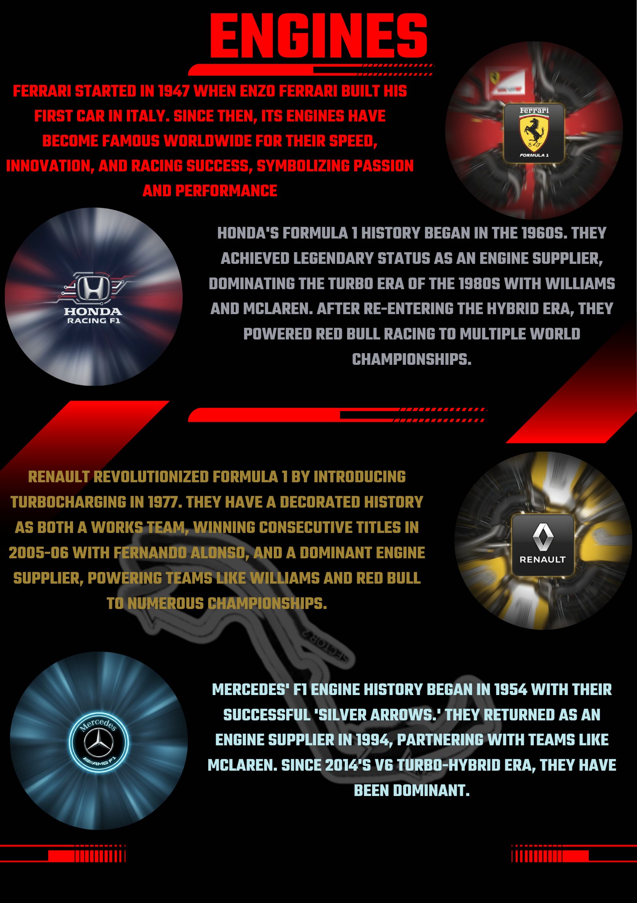

Ferrari
- RAW DATA:-
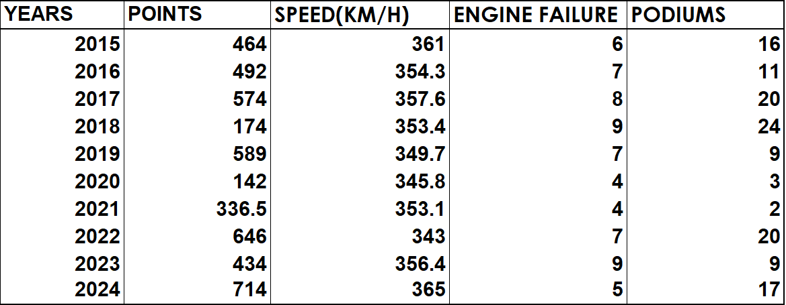

GRAPHICAL REPRESENTATION OF THE VARIABLES
- Why is there need of graphical representation?
->Graphical representations are essential for revealing underlying trends, patterns, and outliers within a dataset.
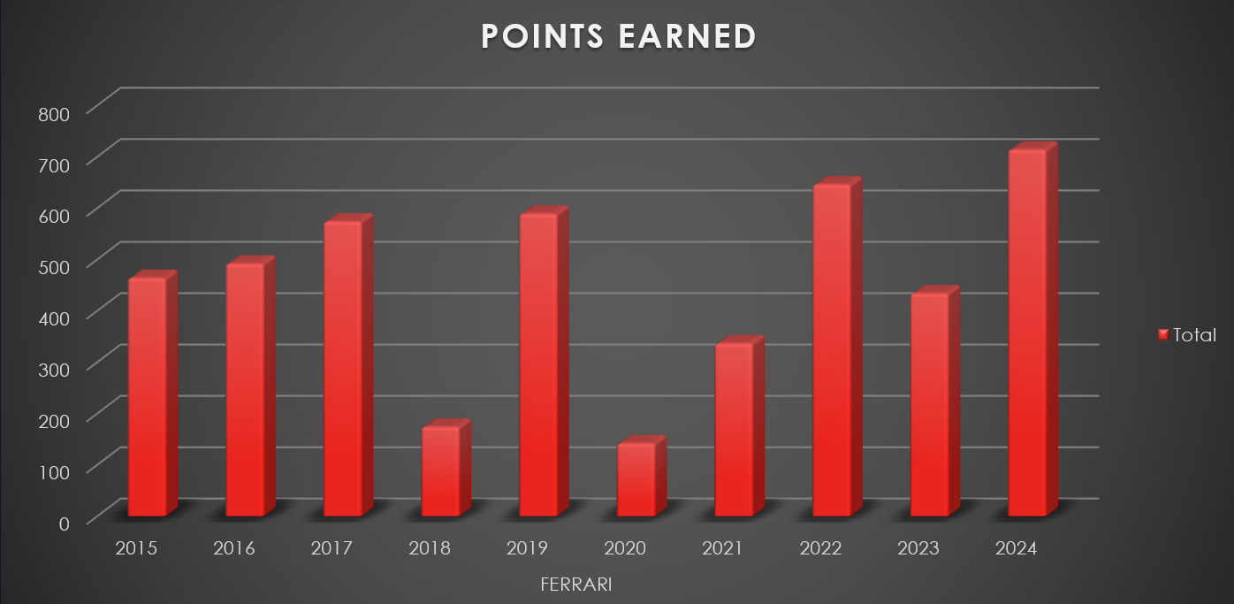
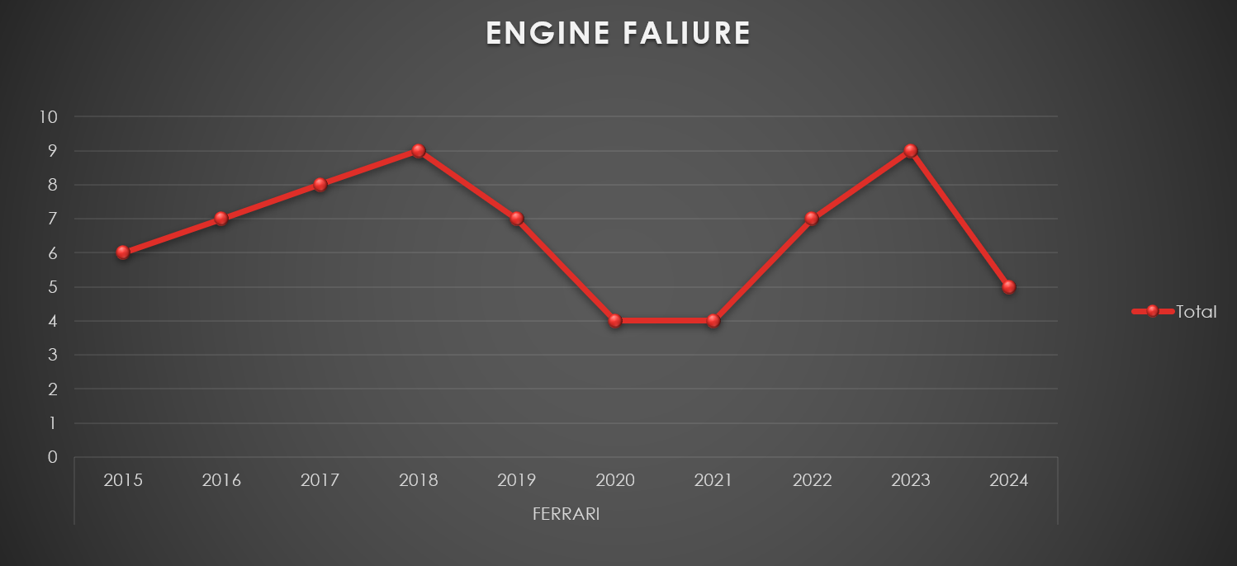
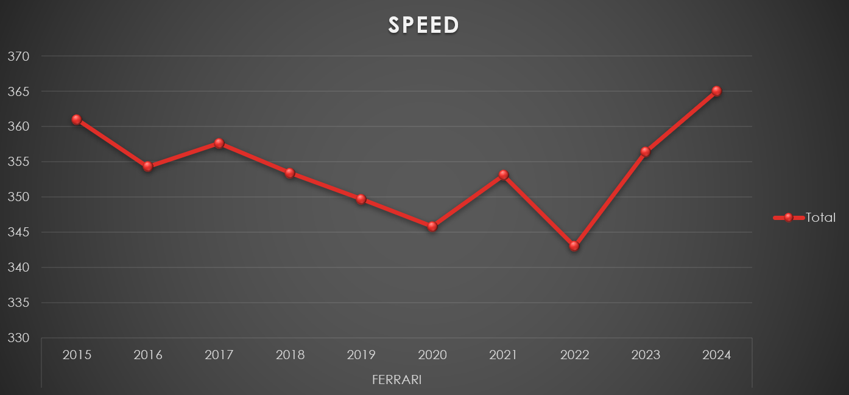
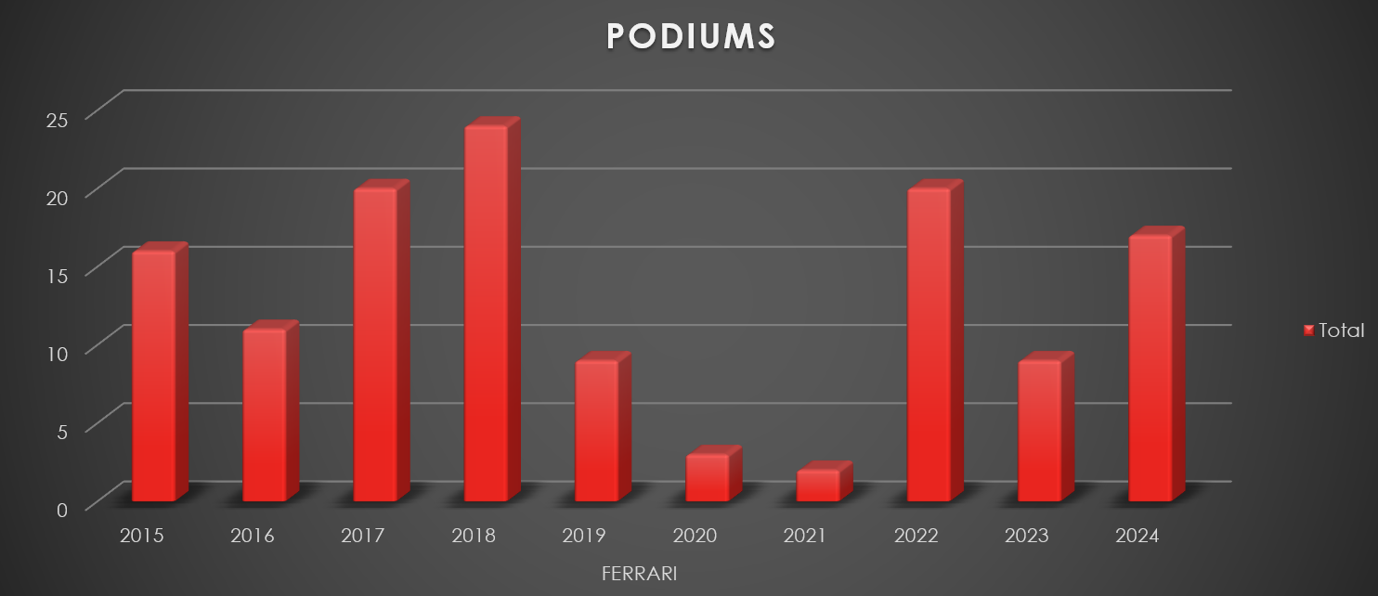
OBSERVATION :-
From 2015 to 2024, Ferrari’s F1 performance shows notable fluctuations across speed, podiums, points, and engine failures. The top speed declined until 2020, followed by a strong recovery peaking in 2024, while podium finishes peaked in 2018 before dipping sharply in 2019 and 2020, then rebounding in recent years. Points earned closely mirror the podium trend, with highs before 2019, a slump in 2020 and 2021, and significant resurgence through 2024. Engine failures peaked in 2018 and 2023, suggesting reliability challenges during those seasons, but Ferrari managed to reduce failures by 2024 even as performance improved. Overall, these graphs highlight Ferrari’s cycles of competitiveness, recovery, and technical evolution over the decade.
COMPUTATION OF DESCRIPTIVE MEASURES

- ARITHEMATIC MEAN:-
Arithmetic mean is the average of numbers, found by dividing their sum by count. It’s important for analysing data, finding central tendency, and comparing datasets.
Formula:
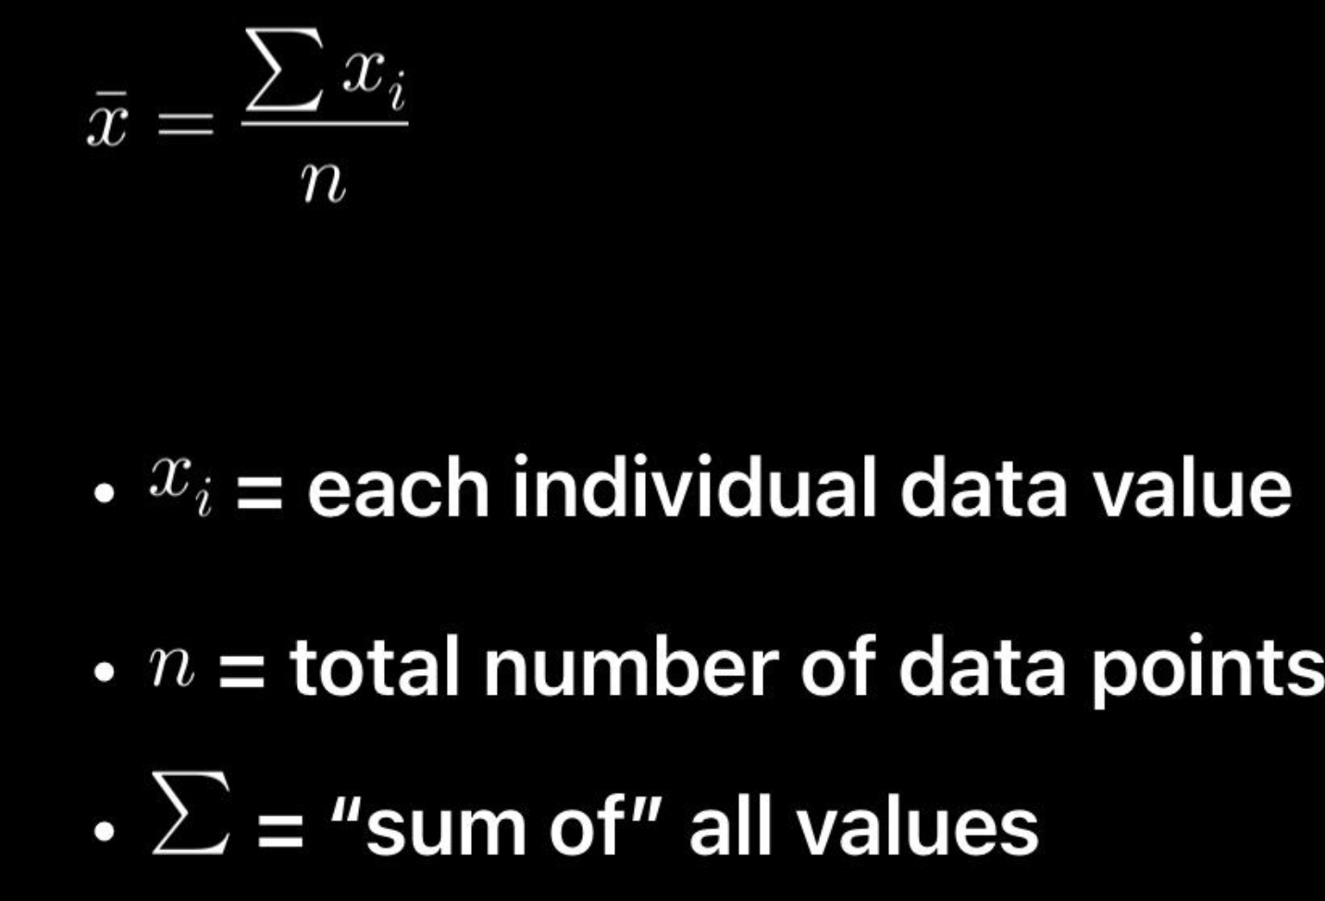

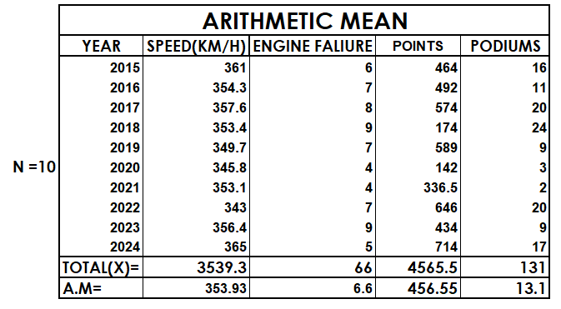

- MEDIAN:-
Median is the middle value of a data set when arranged in order. It’s important to measure central tendency, especially for skewed data. No fixed formula—sort and pick the middle. Types: odd-sized data (middle value) and even-sized data (average of two middle values).
Formula:
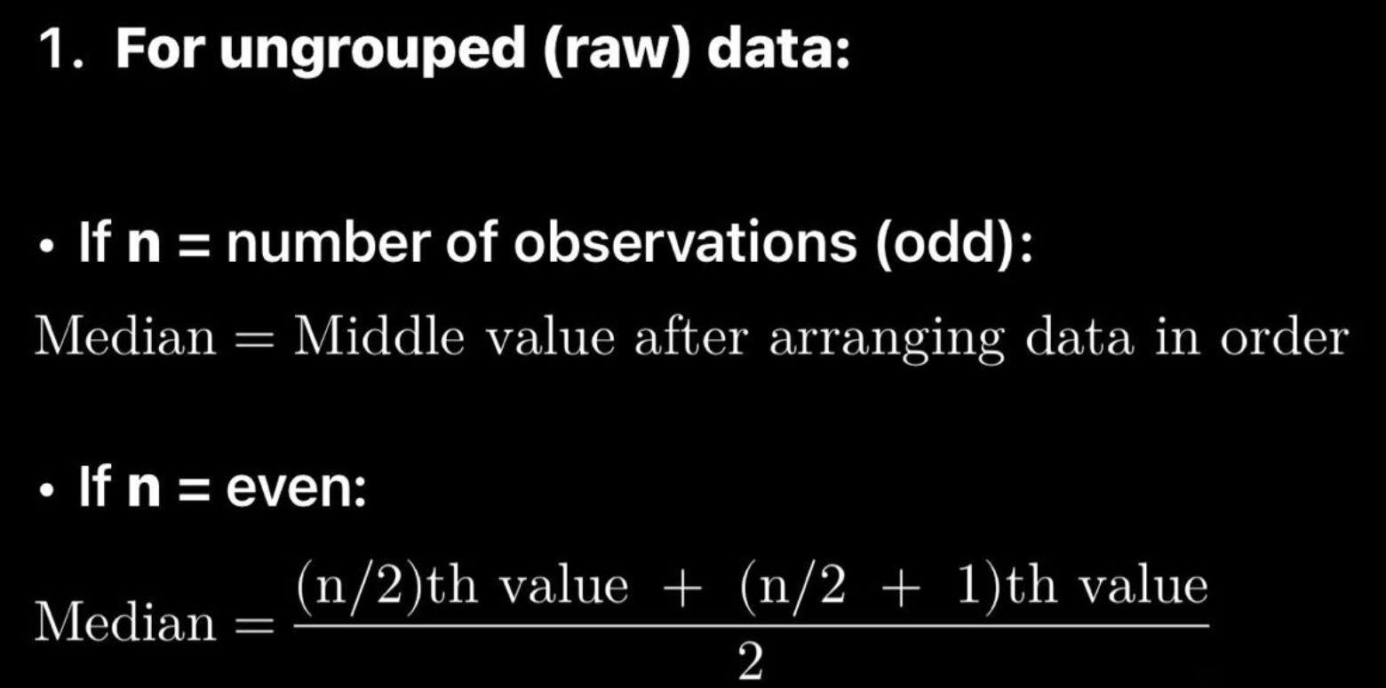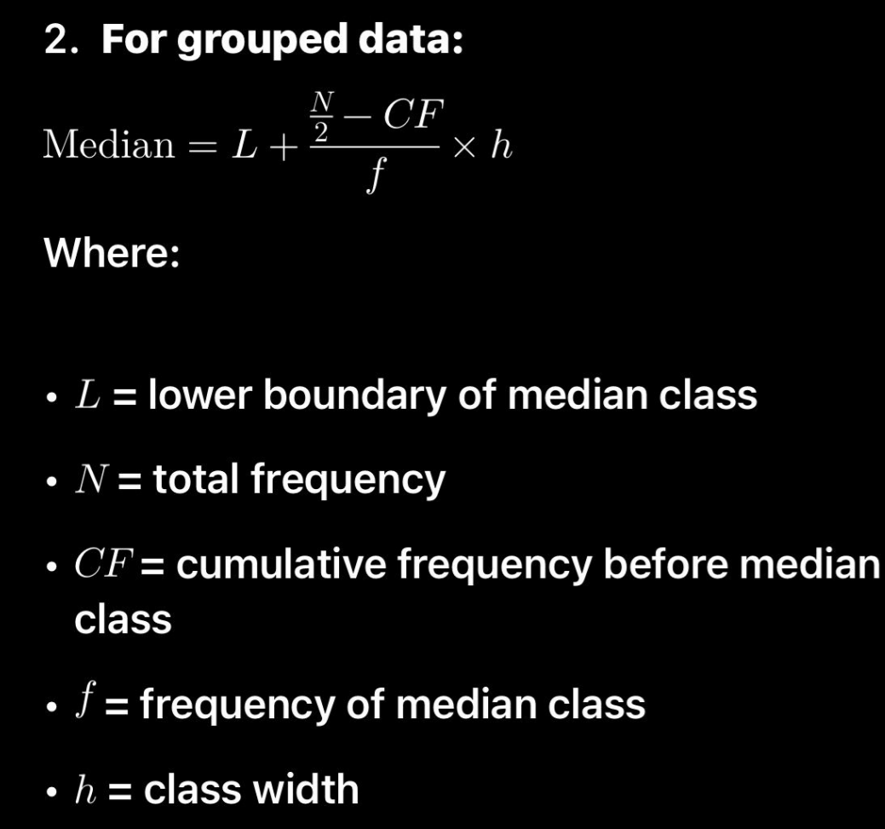

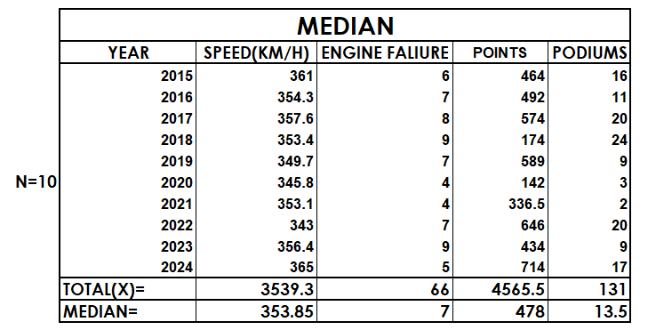
- QUARTILES:-
Quartiles are values that divide a data set into four equal parts, helping us understand how the data is spread. The first quartile (Q1) has 25% of the data below it, the second quartile (Q2) is the median with 50% below, and the third quartile (Q3) has 75% below it. They are useful for identifying outliers, analyzing variability, and creating box plots.
Formula:
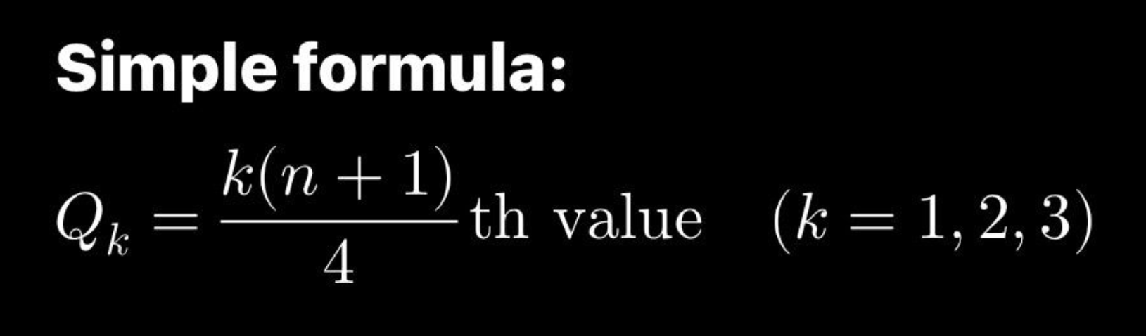

- INTER QUARTILE RANGE (IQR):-
Interquartile Range (IQR) is the range of the middle 50% of data. It shows how spread out the central values are and helps spot outliers.
Formula:
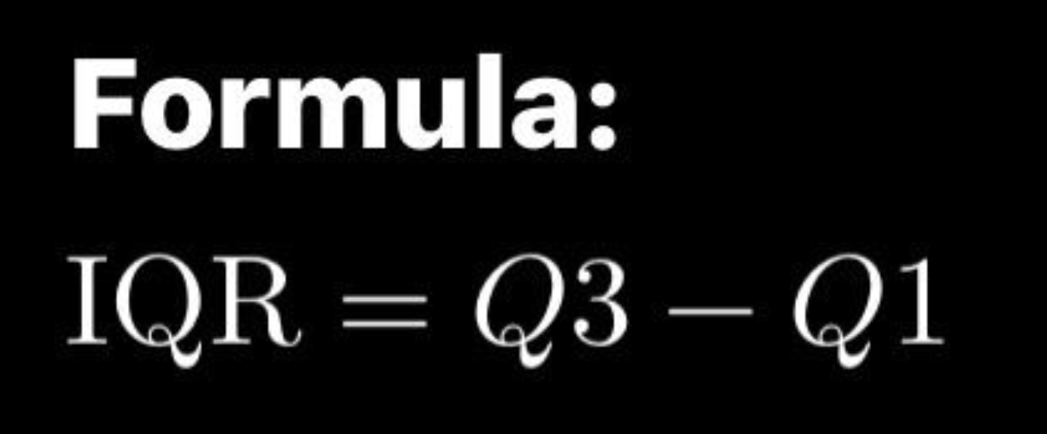
- QUARTILE DEVIATION (QD):-
Quartile Deviation (QD) shows how spread out the middle 50% of data is. It’s simple, stable, and less affected by extreme values.
Formula:
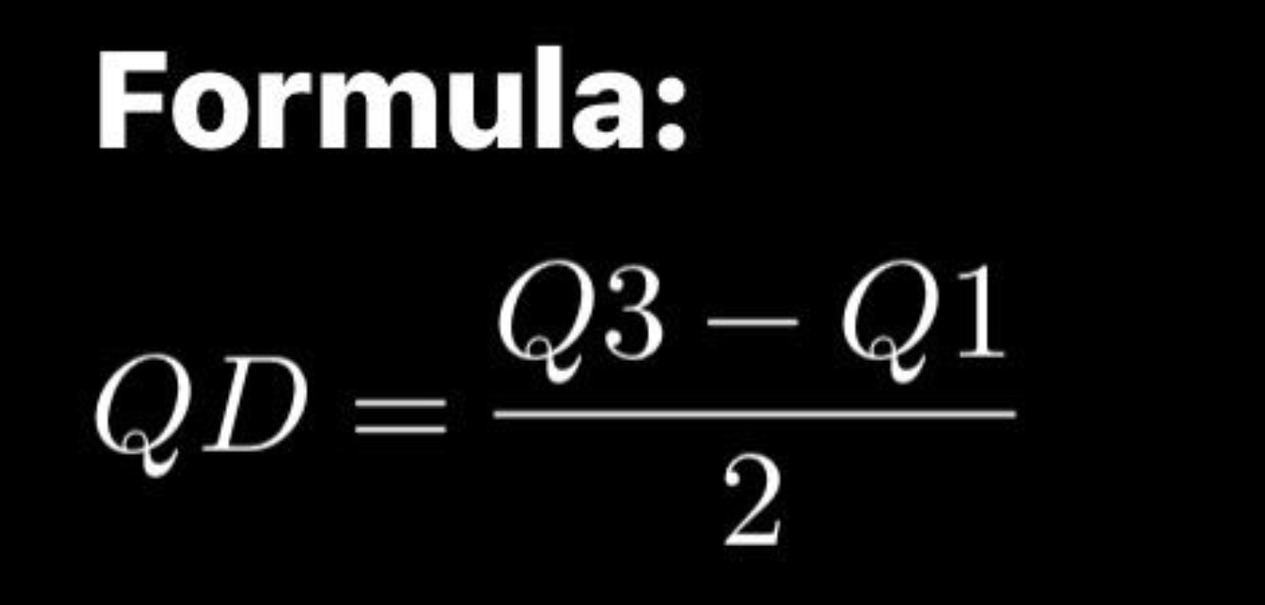

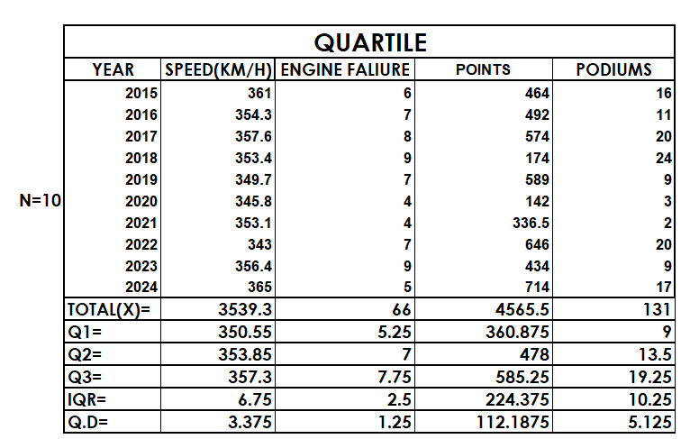
- VARIANCE:-
Variance tells us how much the data values are spread out from the average. It helps understand data consistency and risk.
Formula:
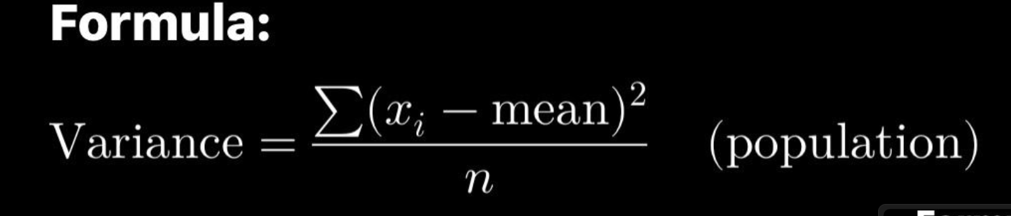

- STANDARD DEVIATION:-
Standard Deviation (SD) shows how much data values usually differ from the mean. It’s easy to interpret and helps understand data spread.Variance tells us how much the data values are spread out from the average. It helps understand data consistency and risk.
Formula:
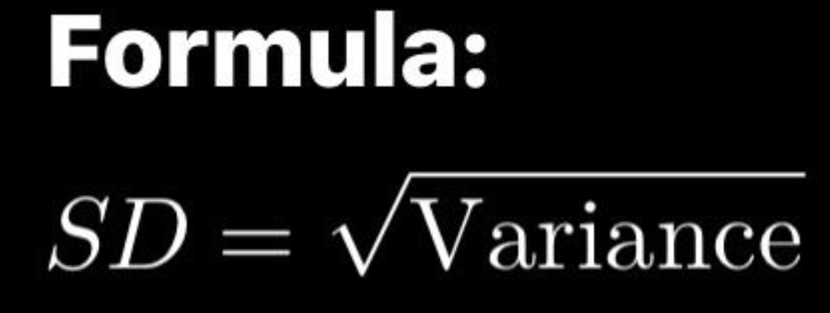
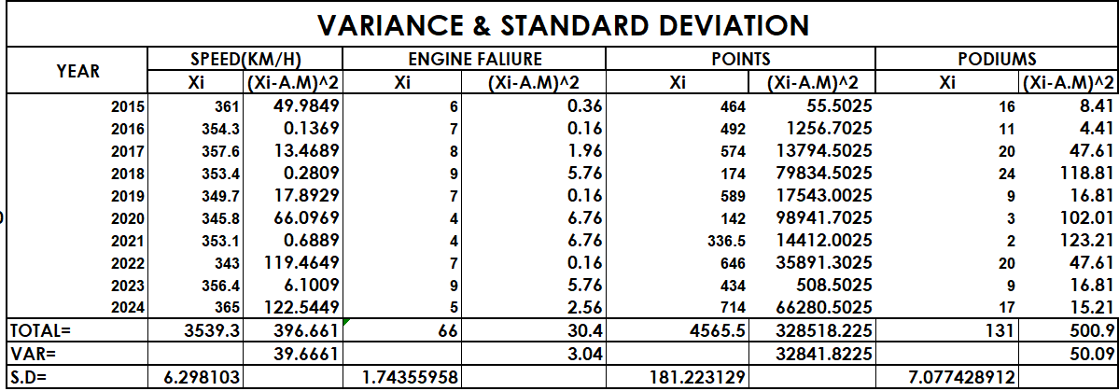

- COEFFICIENT OF VARIATION (CV):-
Coefficient of Variation (CV) shows data spread relative to the mean, making it easy to compare different data sets.
Formula:
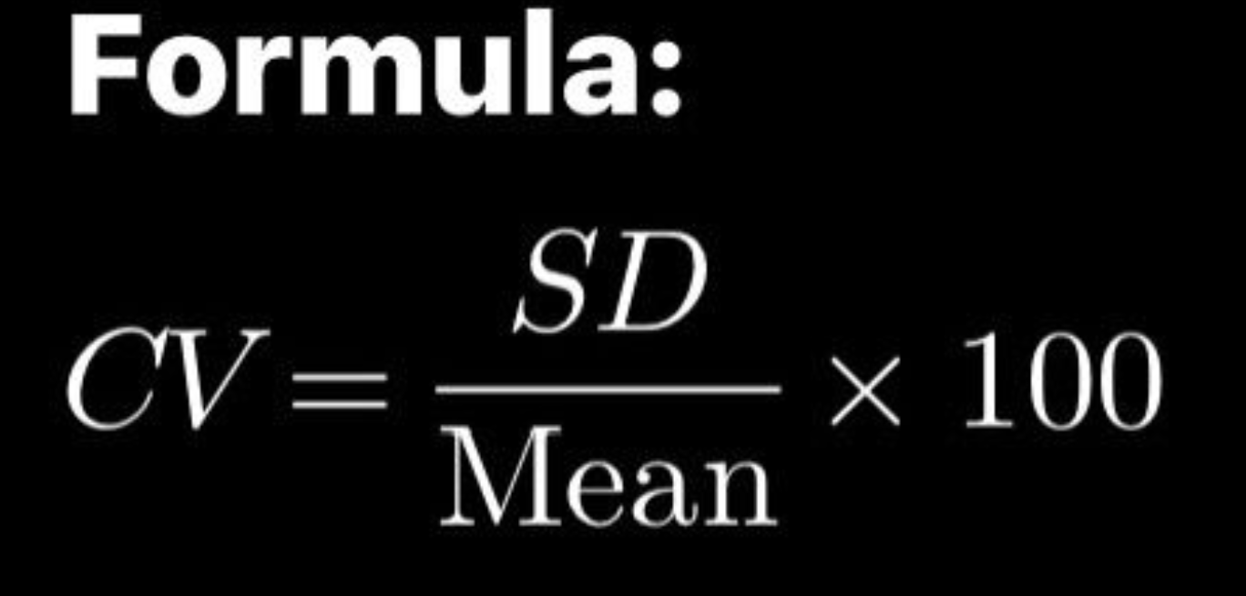

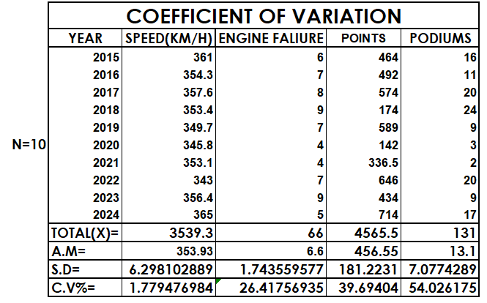

mercedes
- RAW DATA:-
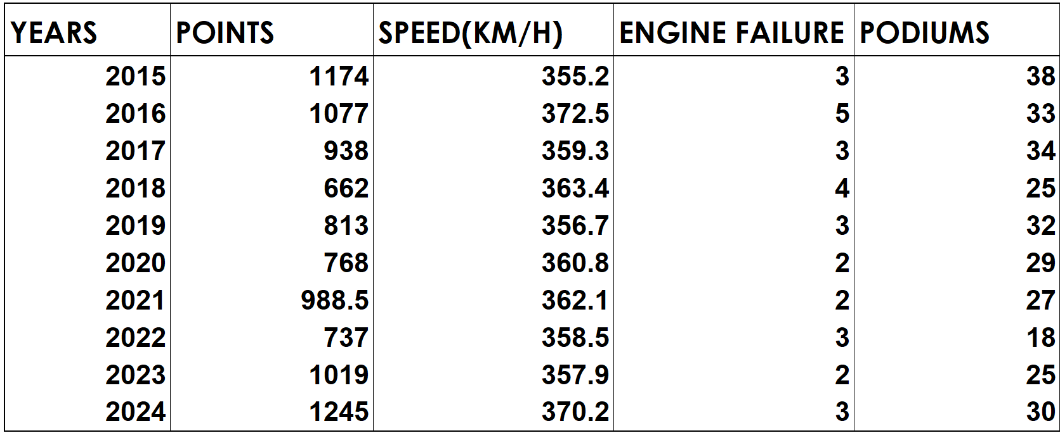

GRAPHICAL REPRESENTATION OF THE VARIABLES
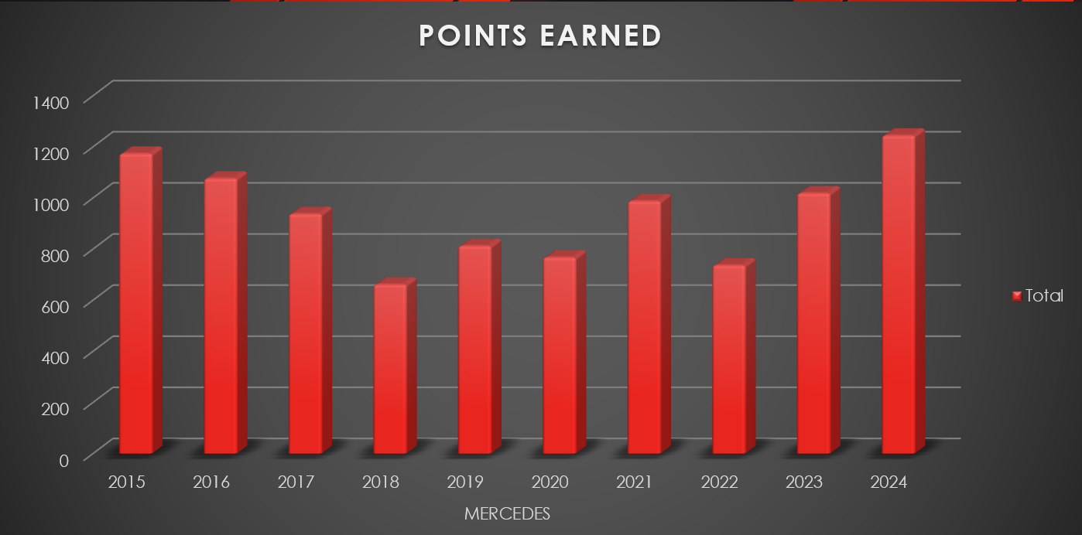

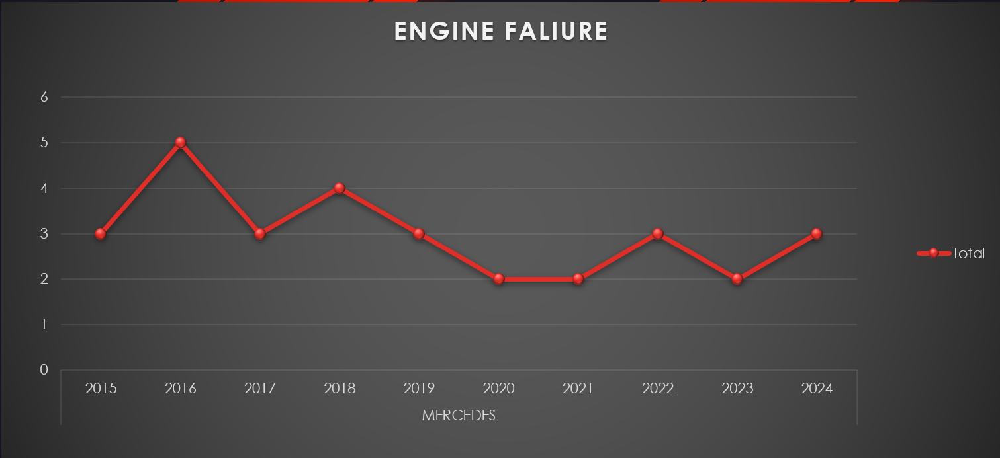

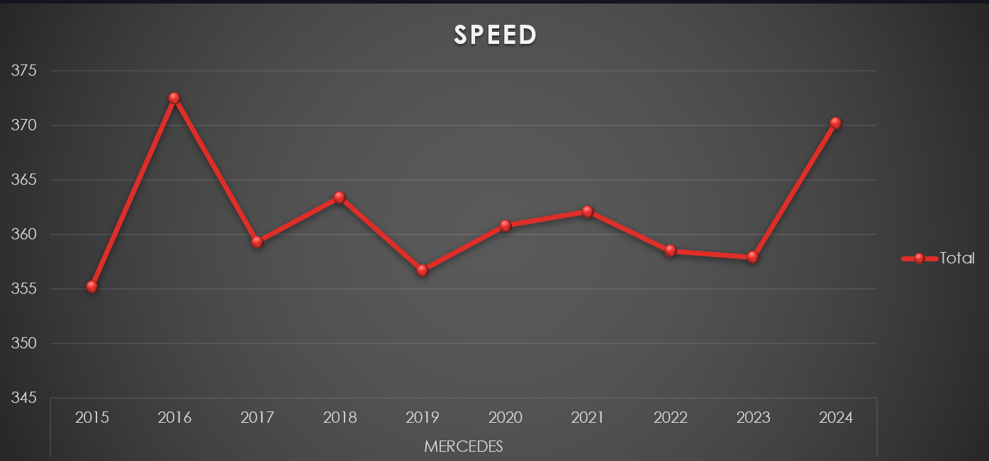
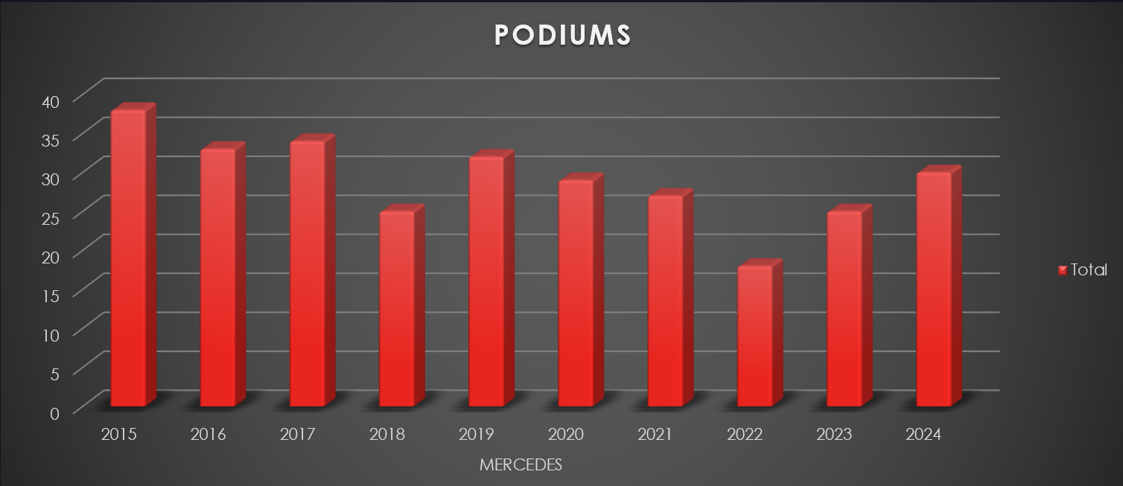

OBSERVATION: -
From 2015 to 2024, the Mercedes F1 team’s graphs reflect a story of competitive consistency and adaptability. Their points and podiums remained high for most of the decade, with only modest dips and a resurgent peak in 2024, demonstrating sustained performance at the top level. The speed chart shows minor fluctuations but generally holds a high standard, mirroring the team’s emphasis on engineering excellence. Engine failures remained relatively low and steady, indicating strong reliability, with only occasional increases that did not significantly impact overall success. Collectively, these trends underscore Mercedes’ ability to maintain elite competitiveness, high speed, and reliability throughout a changing era in Formula 1.
COMPUTATION OF DESCRIPTIVE MEASURES
- ARITHEMATIC MEAN :-
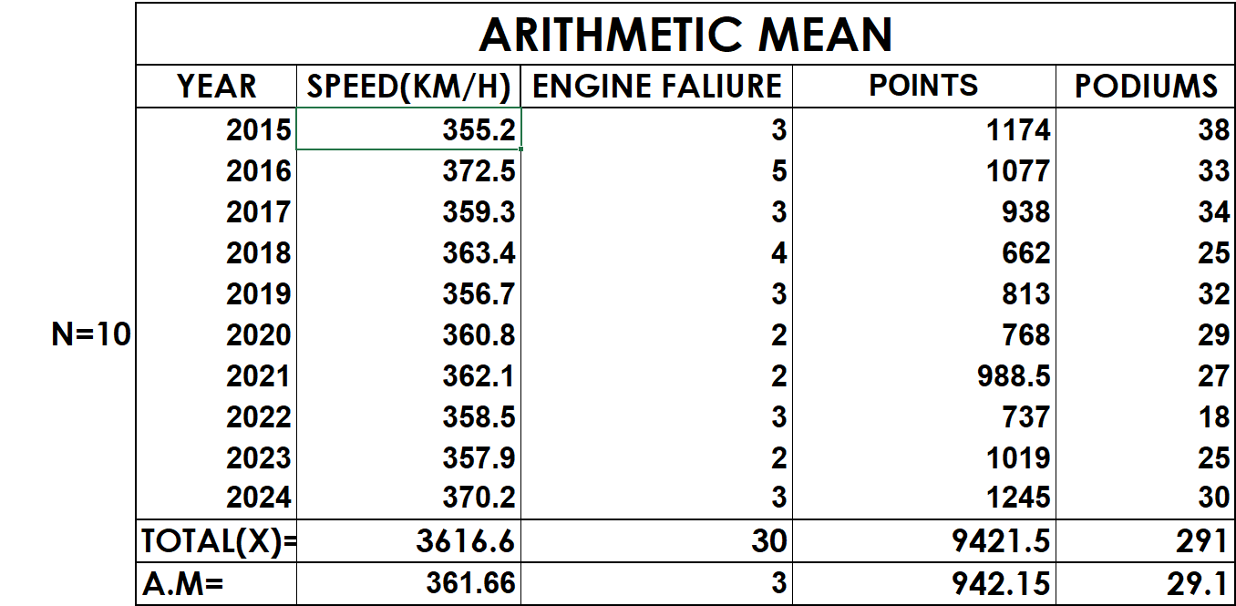
- MEDIAN:-

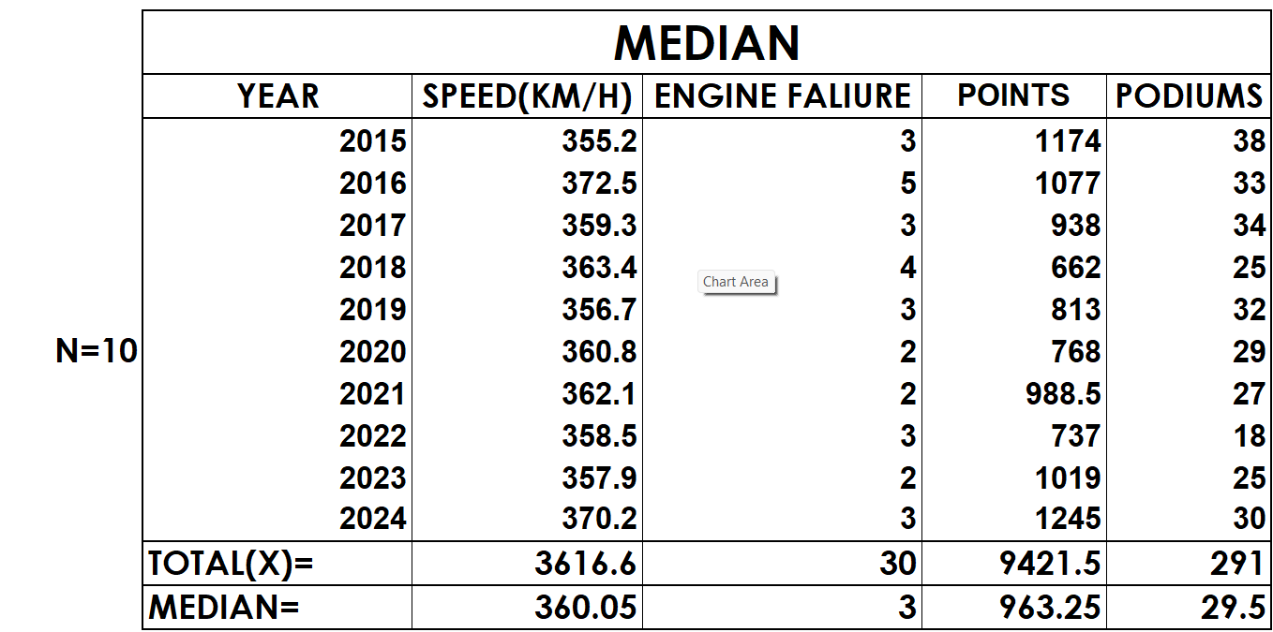

- QUARTILES,INTER-QUARTILE RANGE,QUARTILE DEVIATION:-
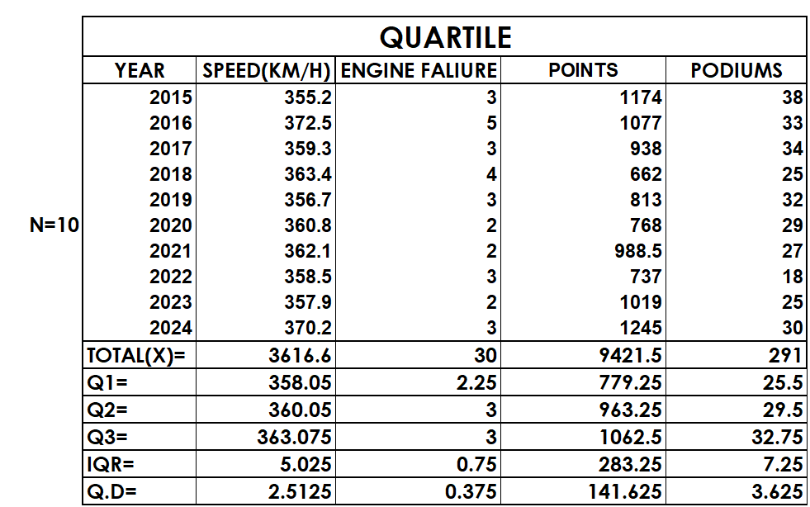

- VARIANCE, STANDARD DEVIATION:-
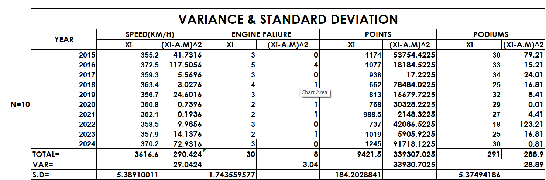

- COEFFICIENT OF VARIATION (CV):-
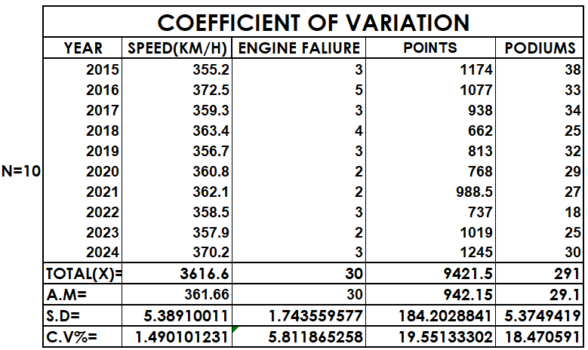
RENAULT
- RAW DATA:-
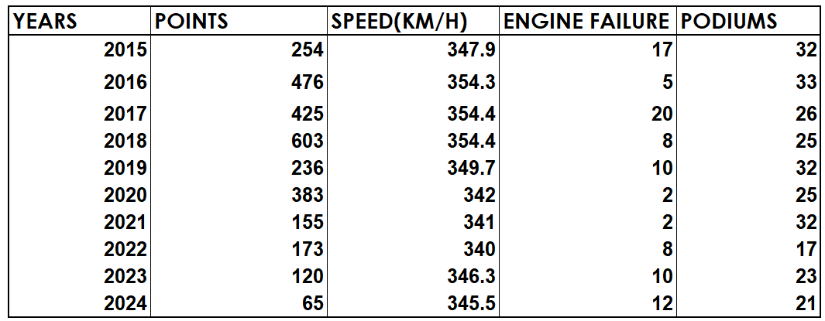

GRAPHICAL REPRESENTATION OF THE VARIABLES
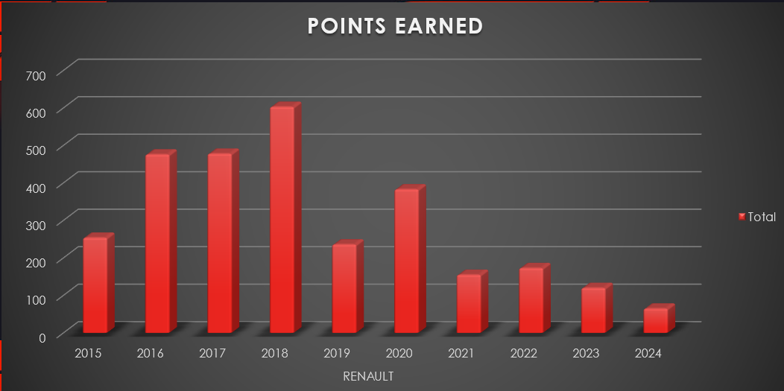

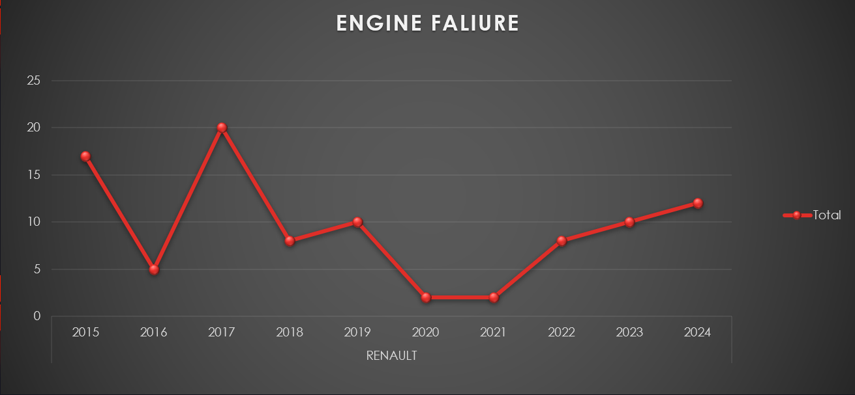

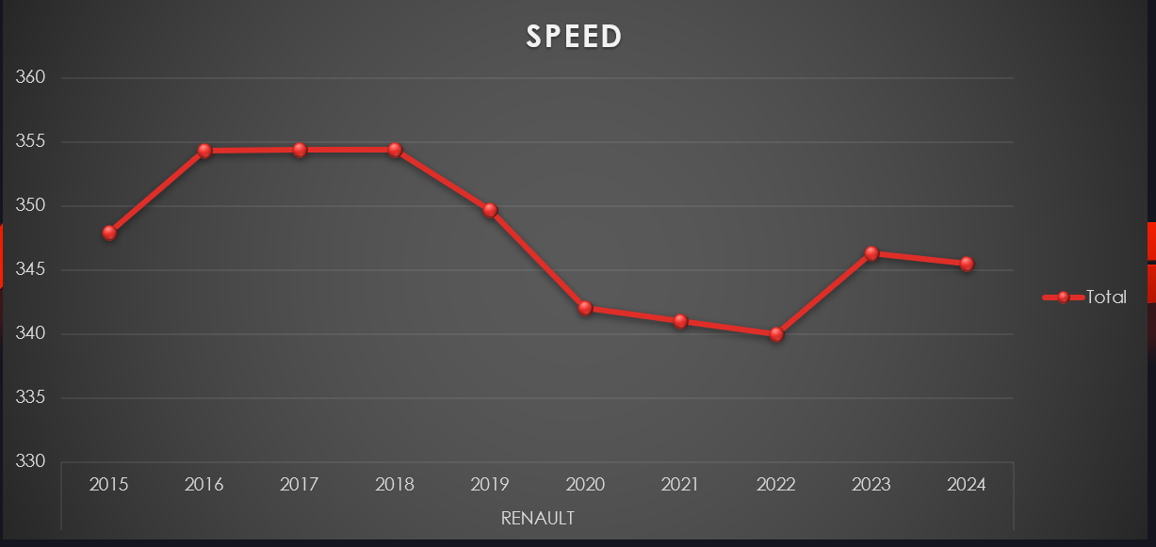
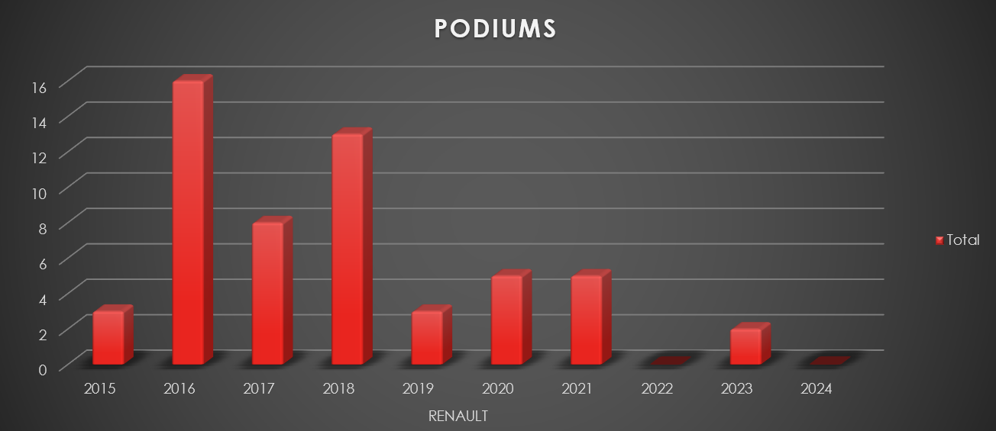
OBSERVATION: -
From 2015 to 2024, the Renault F1 team’s data highlights pronounced variability in performance. The team experienced its highest points and podium tallies in 2018, but both metrics declined steeply in subsequent years, reaching minimal values by 2023 and 2024. Speed followed a similar trend, initially stable and then dropping off after 2019 with only a slight recovery near the end of the period. Engine failures fluctuated markedly, peaking in several years—most notably 2017 and again rising toward 2024—reflecting persistent reliability concerns. Overall, the graphs illustrate Renault’s early surge followed by a sharp decline in form, underscored by both technical and competitive struggles in the most recent seasons.
COMPUTATION OF DESCRIPTIVE MEASURES
- ARITHEMATIC MEAN :-
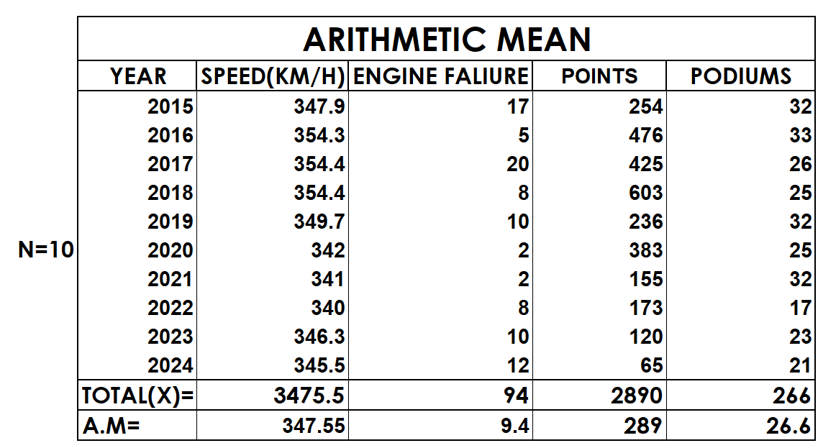

- MEDIAN:-
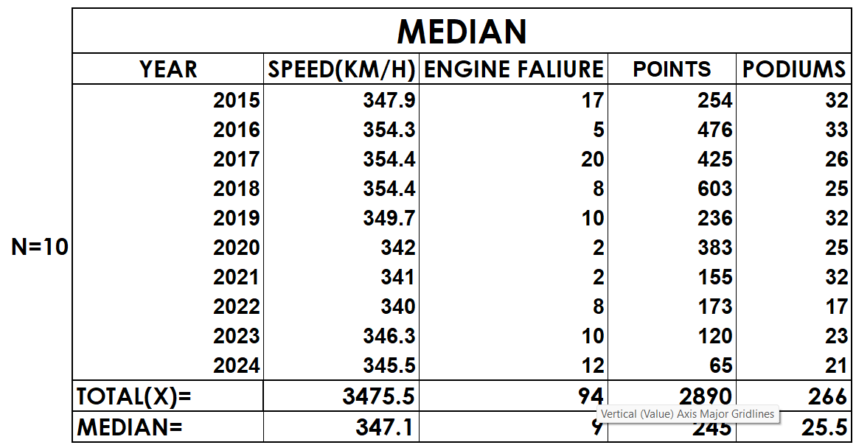
- QUARTILES,INTER-QUARTILE RANGE,QUARTILE DEVIATION:-
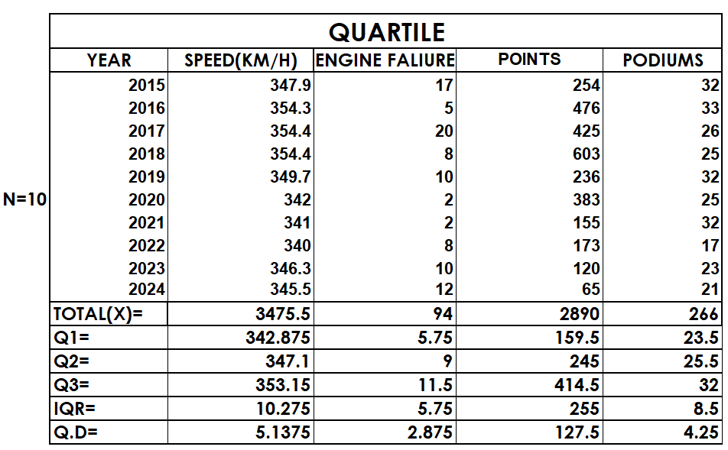

- VARIANCE, STANDARD DEVIATION:-
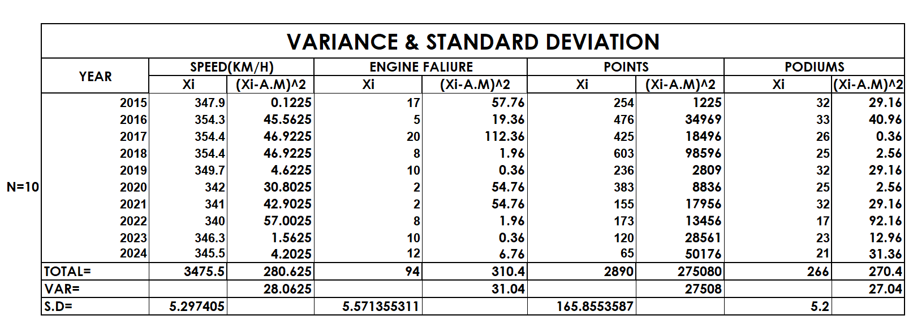

- COEFFICIENT OF VARIATION (CV):-
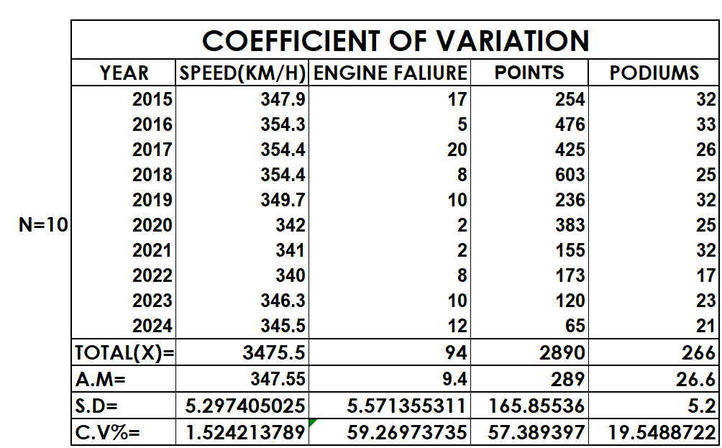

Honda

- RAW DATA:-
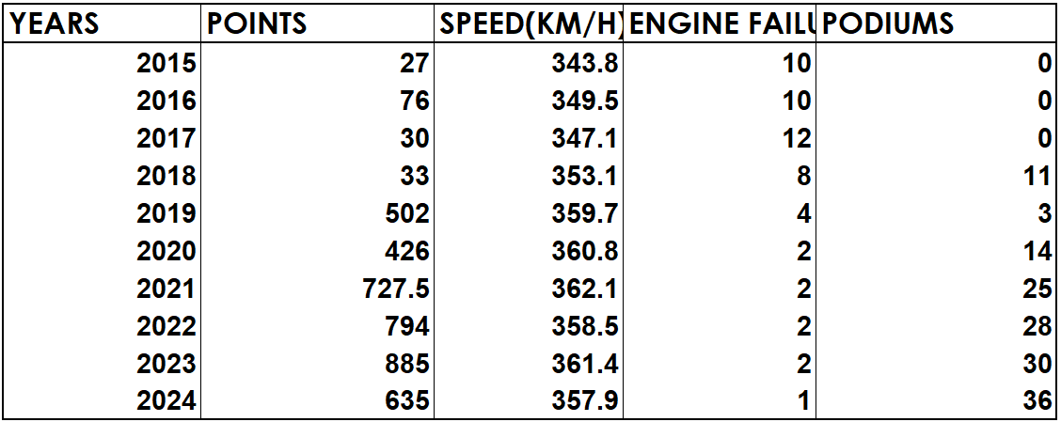

GRAPHICAL REPRESENTATION OF THE VARIABLES
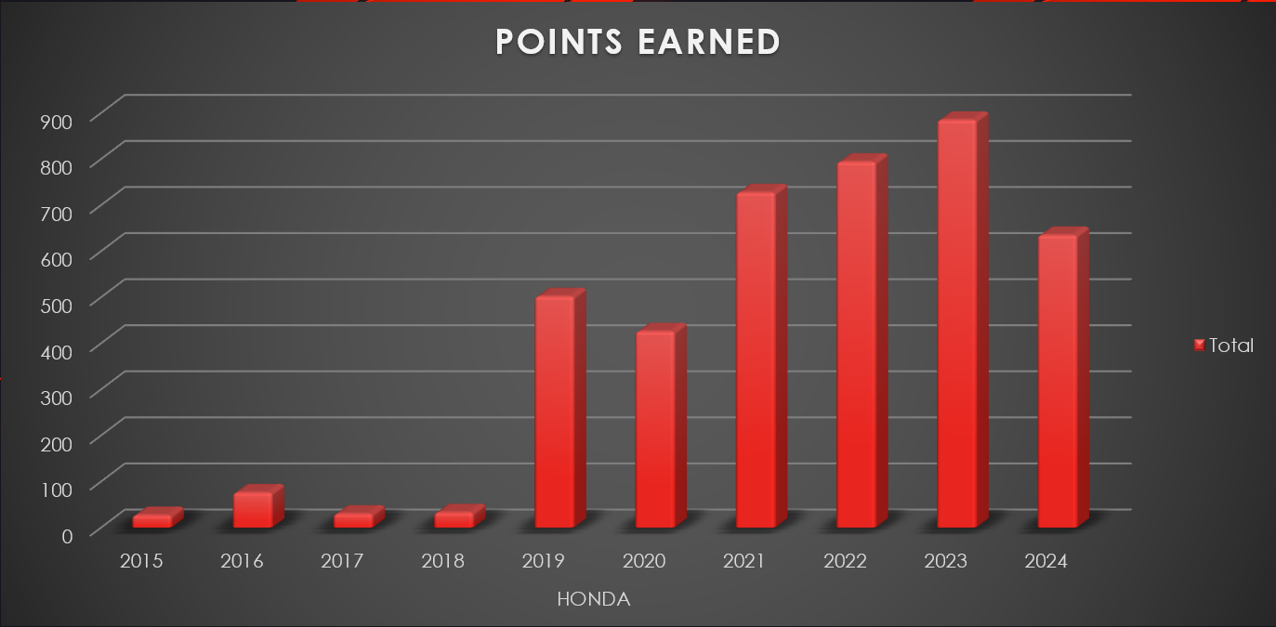

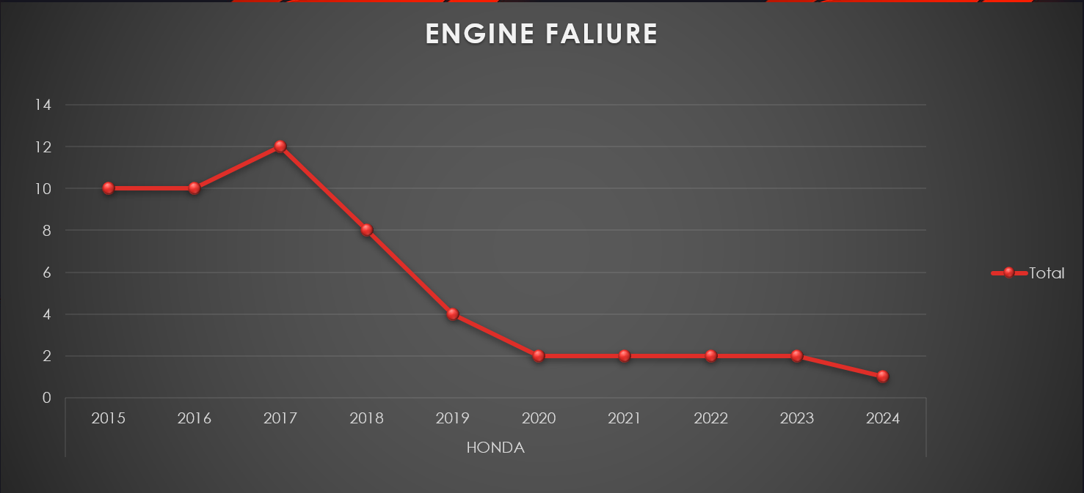

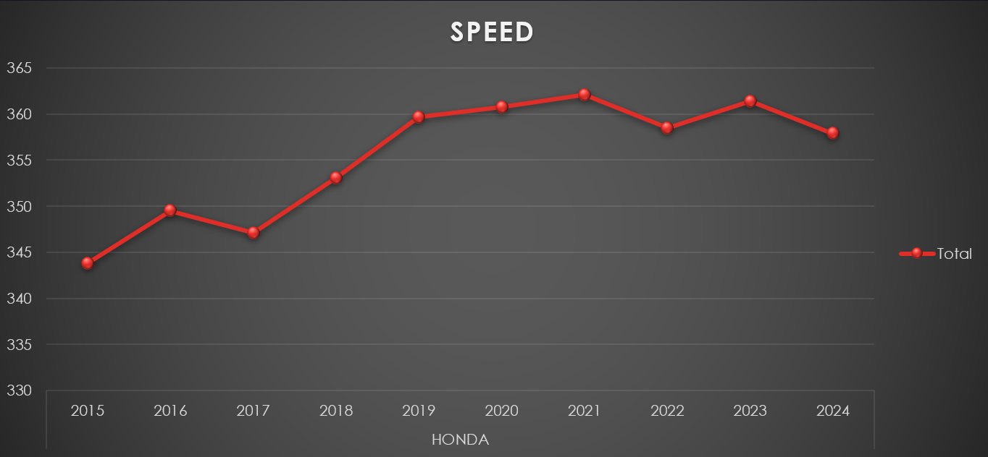
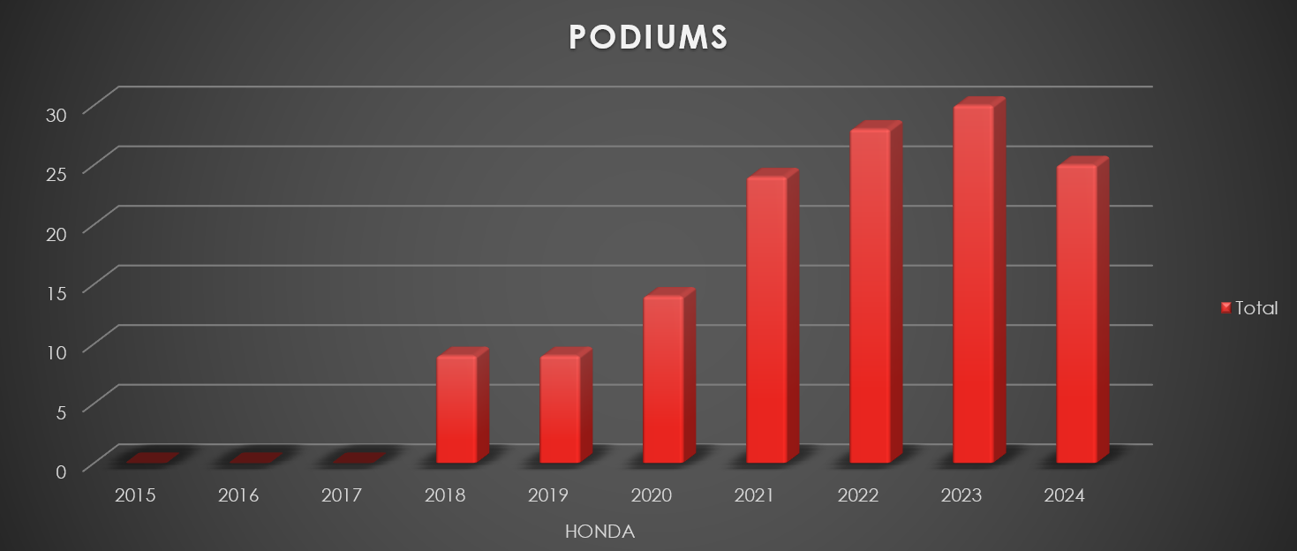
OBSERVATION: -
The Honda F1 team's journey from 2015 to 2024 shows a remarkable transformation. Initially, they struggled with poor performance, frequent engine failures, and low points and podium finishes. However, from 2019 onward, Honda made significant strides in speed, reliability, and competitiveness, resulting in a sharp increase in points and podiums, peaking around 2022-2023. Their engine reliability also improved greatly, dropping failures to a minimum in recent years. This evolution highlights Honda's resilience and technical progress, culminating in becoming a top contender in Formula 1 before their exit in 2021, leaving a lasting mark on the sport.
COMPUTATION OF DESCRIPTIVE MEASURES
- ARITHEMATIC MEAN :-
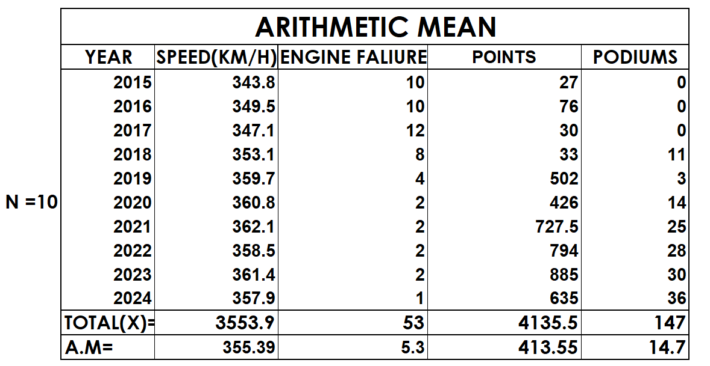
- MEDIAN:-
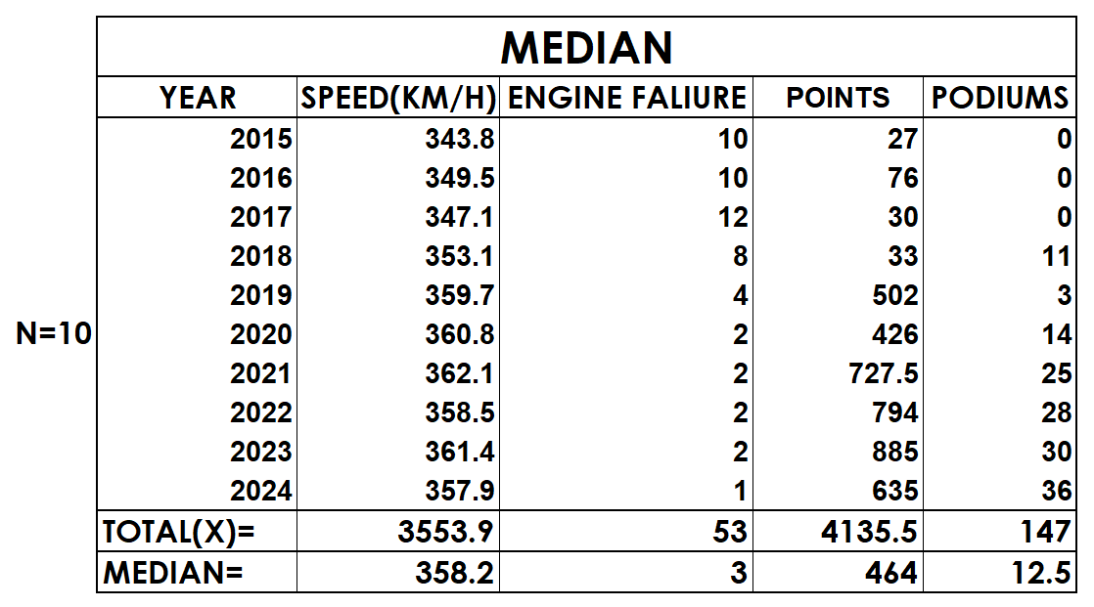

- QUARTILES,INTER-QUARTILE RANGE,QUARTILE DEVIATION:-

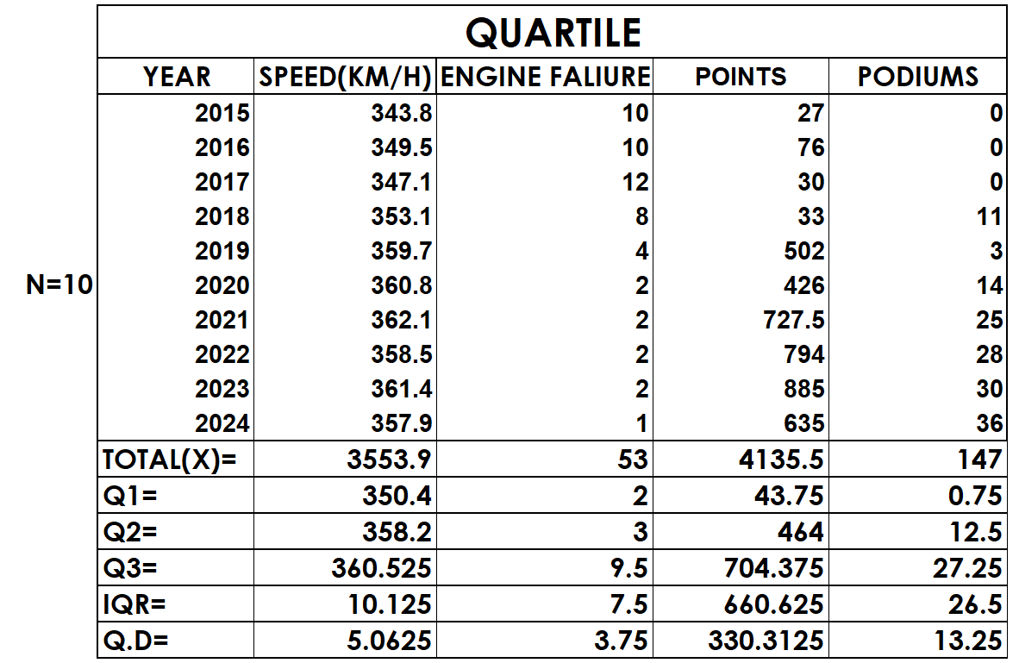

- VARIANCE, STANDARD DEVIATION:-
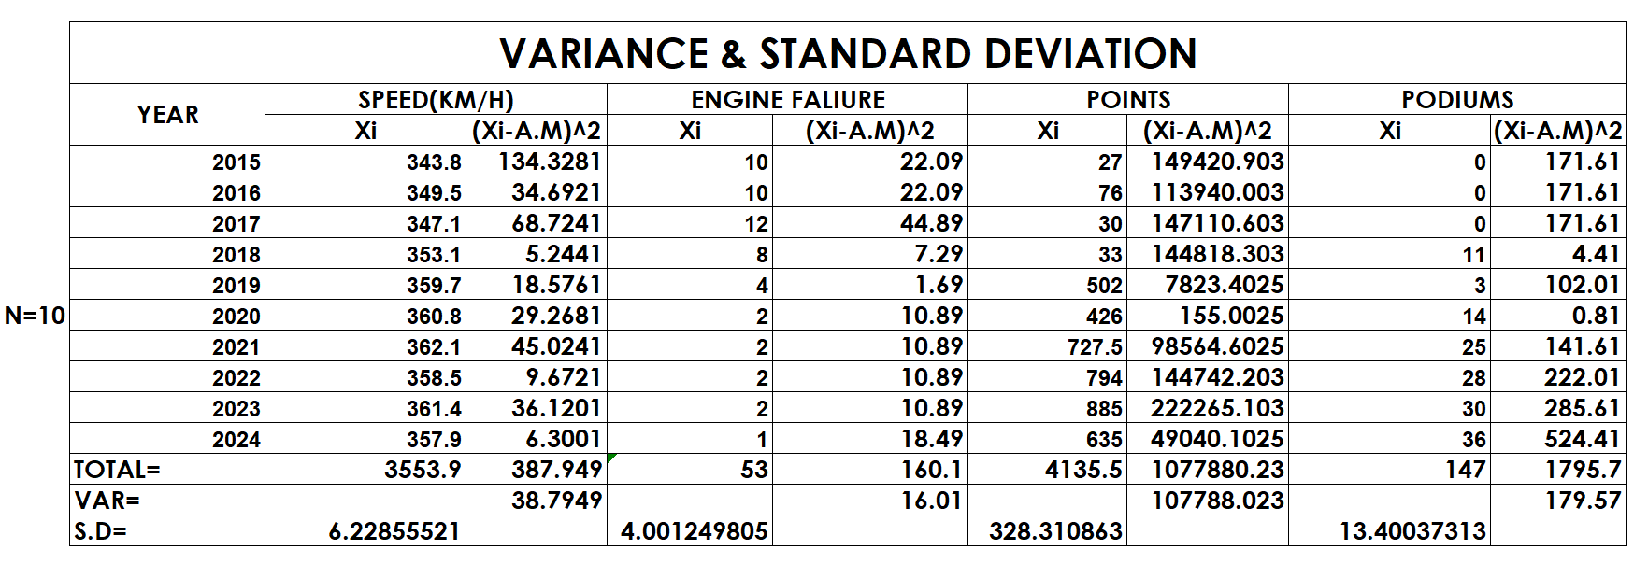

- COEFFICIENT OF VARIATION (CV):-
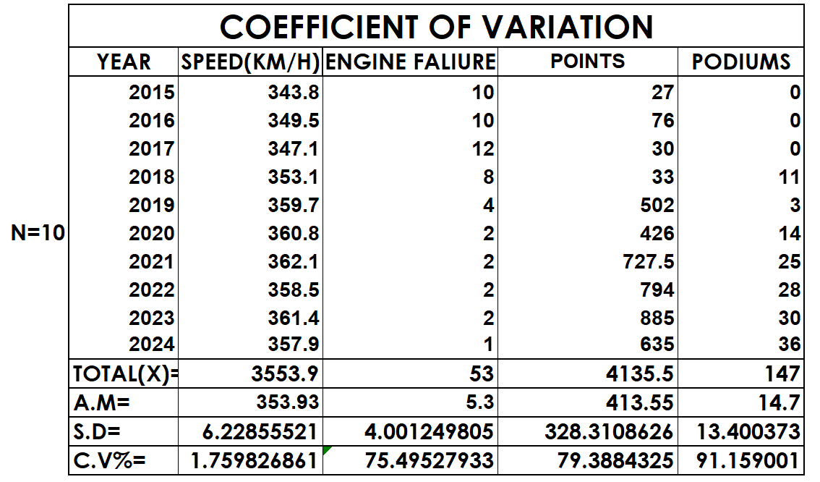

Comparing STATISTICAL MEASURES
- ARIMETHIC MEAN:-
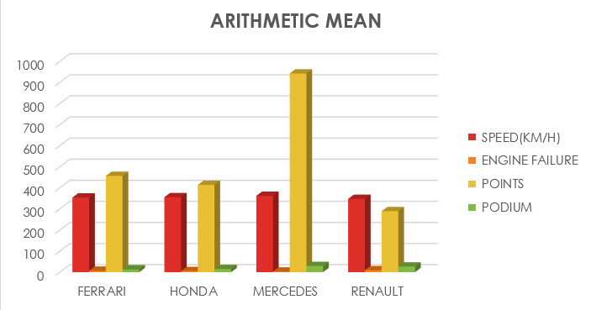
Comparing the arithmetic means from 2015 to 2024, Mercedes-powered teams stand out with the highest average points (942.15), podiums (29.1), top speed (361.66 km/h), and the lowest engine failures (3), highlighting their consistent dominance and reliability. Honda teams, after a slow start, show strong recent performance with a solid average speed (355.39 km/h), low engine failures (5.3), and substantial points (413.55), indicating a sharp upwards trend in competitiveness. Ferrari maintains a high average speed (353.93 km/h) and points (456.55), but a higher engine failure rate (6.6) and moderate podiums (13.1) reflect some inconsistency. Renault teams lag behind with the lowest averages in speed (347.55 km/h), points (289), and podiums (26.6), and the highest engine failures (9.4), pointing to persistent performance and reliability challenges over this period

- MEDIAN:-
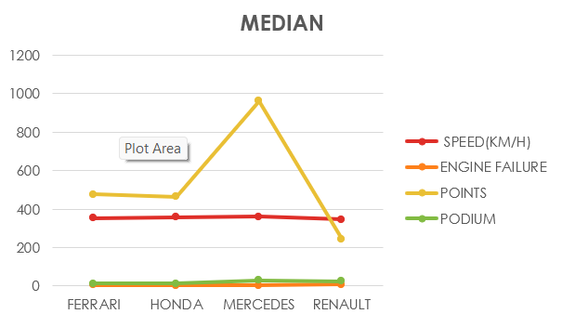

The median statistics from 2015–2024 reinforce Mercedes’ overall superiority, with the highest median speed (360.05 km/h), points (963.25), podiums (29.5), and low engine failures (3), reflecting consistent top-tier results and reliability. Honda’s median values show major progress, with strong median speed (358.2 km/h), points (464), and only 3 engine failures, confirming their surge to competitive form in recent seasons. Ferrari’s median performance is solid but not dominant, with speed at 353.85 km/h, 478 points, and 13.5 podiums, but a higher median engine failure count (7), indicating more frequent reliability issues. Renault’s median numbers are lower in points (249), speed (347.1 km/h), and higher in engine failures (7), despite a respectable 25.5 podiums, highlighting less consistent competitiveness and ongoing technical struggles compared to the other engine suppliers.

- QUARTILES,INTER-QUARTILE RANGE,QUARTILE DEVIATION:-
The quartile analysis from 2015–2024 highlights Mercedes’ consistent advantage: their Q2 (median) values for speed (360.05 km/h), points (963.25), and podiums (29.5) remain the highest, with low variability as shown by a modest interquartile range (IQR) and quartile deviation (Q.D.), further supported by low engine failures. Honda is next, posting solid median results for speed (358.2 km/h), podiums (12.5), and points (464), with an IQR that suggests steady improvement and lower engine failures. Ferrari shows slightly lower medians and higher engine failure rates, with pronounced variability in points and speed, while Renault displays the greatest variance, lowest median scores in speed (347.1 km/h), and highest failures, emphasizing their inconsistent results and technical challenges. Overall, Mercedes excels in both performance and reliability, Honda demonstrates progress and growing consistency, Ferrari remains competitive but less stable, and Renault lags in performance with notable inconsistency.

- COEFFICIENT OF VARIATION (CV):-
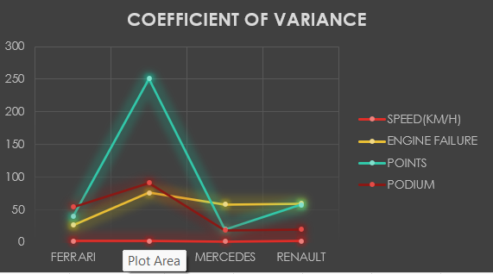

The coefficient of variation (C.V.%) highlights how consistent each F1 engine supplier’s results have been from 2015 to 2024. Mercedes exhibits the best overall stability, with very low C.V.% values for speed (1.49%), points (19.6%), and podiums (18.5%), plus a remarkably low variation in engine failures (5.8%), reinforcing their reputation for both performance and reliability. Honda’s speed C.V.% (1.52%) is similarly low, but engine failures (59.3%) and points (57.4%) are much higher, reflecting their dramatic mid-period turnaround. Ferrari shows modest variation in speed (1.78%) but higher point and podium C.V.% values near 40–54%, evidencing more inconsistency. Renault’s coefficients are the highest for most metrics—especially engine failures (59.3%) and points (57.4%)—demonstrating the greatest performance fluctuations and technical instability among all four suppliers. These trends confirm Mercedes’ unrivaled steadiness, Honda’s rapid improvement trajectory, and Ferrari’s and Renault’s greater variability in F1 results over the decade.
ComparinG VARIABLES
- TOP SPEED:-
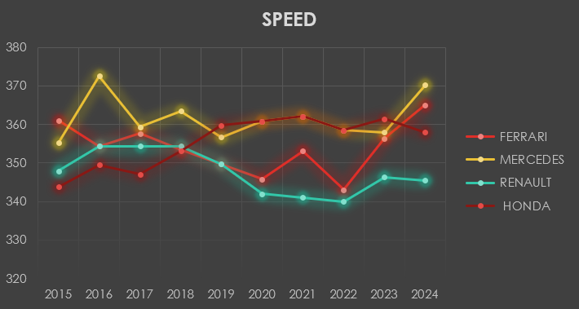
Key Observations:-
• Mercedes: Highest and most consistent performance. Notably peaked in 2016 and 2024.
• Ferrari: Strong early performance but a noticeable dip in 2020, rebounding with the top speed in 2024.it generally ranks second.
• Renault: Fluctuated and generally had the lowest top speeds post-2020.
• Honda: Started lowest but made huge gains, particularly from 2019 onward, matching or surpassing top competitors.

Trends:-
• Mercedes maintains a technological edge in engine speed, critical for straight-line performance and overall competitiveness.
• Honda's dramatic rise in the late 2010s and early 2020s positions it as a serious challenger, especially as seen in their 2023 figure.
• Ferrari and Renault show inconsistency, with their ranking varying depending on regulatory changes and internal development cycles. Ferrari peaks with the highest speed in 2024.

- POINTS:-
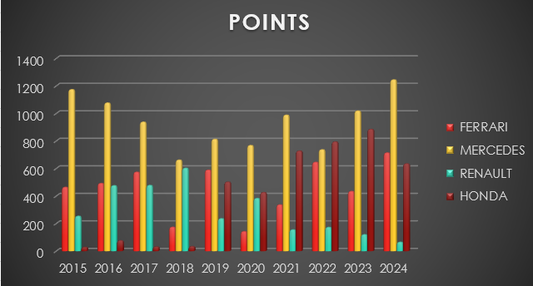
Key Observations:-
•Mercedes: Maintained a championship-dominant run, peaking in 2024 with 1245 points. No other engine comes close, especially in the title-winning seasons.
•Ferrari: Strong contender, especially in 2018 and 2024, but suffered significant point drops in 2020 and 2021.
•Honda: Weak presence before 2019, but becomes a powerhouse through the 2020s, reaching a high of 885 points in 2023.
•Renault: After a competitive 2018, points plummet, highlighting performance or reliability challenges.

Trends:-
•Mercedes and Ferrari are the historical heavyweights, but Honda’s recent surge demonstrates a successful engine development strategy and partnership shift.
•Renault's inability to keep pace is evident in declining points, particularly after 2019.

- PODIUMS:-
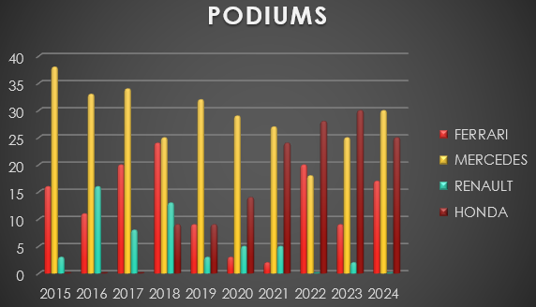
Key Observations:-
•Mercedes: Consistently achieves podiums, though the raw number sometimes lags behind other suppliers (especially Renault in certain years).
•Ferrari: Mostly strong, with high podium tallies in 2017 and 2024, but hit significant dips in the early 2020s.
•Renault: Surprisingly competitive in podiums during 2015-2017, outpacing Mercedes and Ferrari, but performance drops notably after 2017.
•Honda: After a slow start, becomes a podium powerhouse in the last three years, matching or exceeding every engine supplier.

Trends:-
•Honda’s breakthrough after 2018 led to dominant podium counts in 2023 and 2024, surpassing Mercedes and Ferrari in those years.
•Ferrari and Mercedes maintain top-five presence but do not always match Renault’s podium heights in the mid-2010s.
•Podium analysis reveals Mercedes’ consistent performance, Ferrari’s highs and lows, Renault’s early advantage and later drop-off, and Honda’s massive modern resurgence — heavily shifting the competitive balance by 2023 and 2024.

- ENGINE FAILURE:-
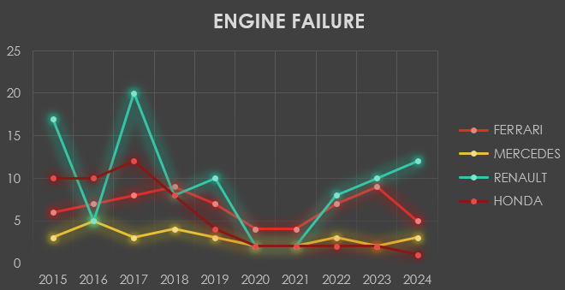
Key Observations:-
•Mercedes: Most reliable overall, typically just 2-5 failures per season, and improved to only 2 failures in 2023.
•Ferrari: Generally reliable but saw spikes in 2018, 2022, and 2023.
•Renault: Highest engine failure rate, especially disastrous in 2015, 2017, and 2024 — which likely had major consequences for competitiveness.
•Honda: Initial problems (10-12 failures per season), but dramatically improved over time, with only 1 failure in 2024.

Trends:-
•Renault’s consistent engine reliability problems are a major competitive disadvantage through the decade.
•Mercedes maintains legendary reliability, and Honda’s improvement positions them as a top performer in recent seasons.

Bibliography
- TOP SPEED:-
- https://racingnews365.com/f1-car-top-speed
- https://racingnews365.com/who-was-fastest-through-the-speed-trap-in-first-practice
- https://www.formula1.com/en/latest/article/drivers-hit-record-speeds-in-mexico.290bsyeyDKmwlemEMcmR8H
- https://www.kaggle.com/code/jtrotman/f1-race-traces-2015
- POINTS:-
- https://www.formula1.com/en/results/2024/team
- https://www.autosport.com/f1/news/which-engine-does-each-f1-team-use-in-2024-/10598000/
- https://www.racefans.net/2017-f1-season/statistics/championship-points/
- PODIUMS:-
- https://www.formula1.com/en/latest/article/f1-2015-season-in-numbers.54n57vwswfHP5RO0WH5CSE
- https://en.wikipedia.org/wiki/2016_Formula_One_World_Championship
- https://global.honda/en/POWEREDbyHONDA/2016_ra616h/
- https://rossoautomobili.com/pages/scuderia-ferrari-formula-1-results-2010-2019
- ENGINE FAILURE:-
- https://www.motorsportweek.com/2024/10/04/how-corporate-mismanagement-has-killed-off-renault-in-f1/?utm
- https://www.espn.in/f1/story/_/id/17726368/mercedes-analysis-reveals-cause-hamilton-engine-failure
conclusion
This analysis looked at the data to see which Formula 1 engine supplier—Mercedes, Ferrari, Honda, or Renault—was the best during the hybrid era from 2015 to 2024. By comparing important stats like points, podiums, top speed, and engine failures, we can see clear differences in how well each of them performed.

The findings clearly show that Mercedes was the top engine supplier of this time. Mercedes-powered teams had the highest average points (942.15), podiums (29.1), and top speed (361.66 km/h). On top of that, they were very reliable, with the lowest average number of engine failures (3). Their consistency is also proven by a low coefficient of variation, which means their great results didn't change much from year to year.
Honda's story is one of a big comeback. After starting with poor results and frequent engine problems, they made amazing technical improvements from 2019 onward. This turnaround is shown by their much-improved reliability, ending with only one engine failure in 2024, and a large increase in points and podiums that made them a top competitor.

Ferrari was a strong competitor, but their performance was up and down. The team had a high average for points (456.55) and speed (353.93 km/h). However, they were held back by inconsistency, which can be seen in their higher average of engine failures (6.6) and significant changes in their results over the years.
The data shows that

Renault faced the biggest challenges with performance and reliability. Over the decade, their teams had the highest average of engine failures (9.4) while also having the lowest average top speed (347.55 km/h) and points (289).

In conclusion, this analysis shows that to stay on top in Formula 1, an engine must be both fast and reliable. Mercedes was a perfect example of this balance and dominated as a result. Meanwhile, Renault's constant engine problems were a major disadvantage. While other suppliers had good moments, Mercedes' ability to be consistently fast and dependable made them the clear standout engine supplier of the 2015-2024 era.



